Alice Reins ® Hoodie Size Chart

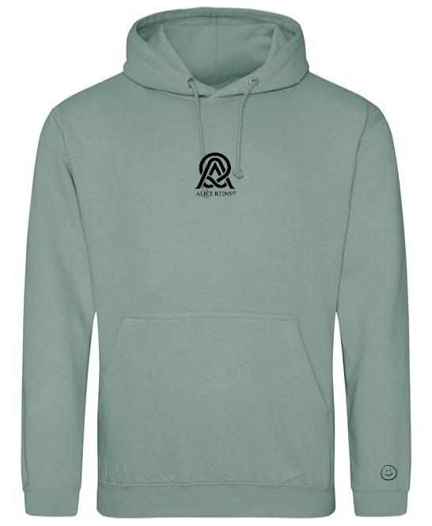
Length
Chest

SIZE CHEST (ins) LENGTH (ins)
S 20.08 26.38
M 22.05 27.56
L 24.02 28.74
XL 25.59 29.92

